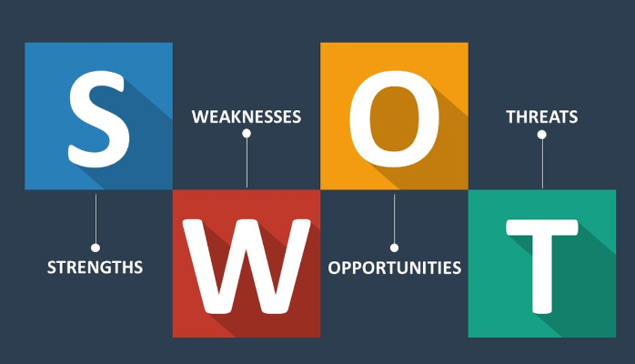

Use the following questions to support you in conducting a self SWOT analysis:

**Strengths (don’t be modest):**

* How do your education, skills, talents, certifications, and connections / networks set you apart from your peers?
* What would your boss or coworkers say are your strengths?
* What resources do you have at your disposal?
* What contributed the most to your past victories?
* What values or ethics do you have that your peers often lack?
* What achievements are you most proud of?

**Weaknesses (be honest):**

* Where are your education, training, or skills lacking? What’s missing and needs improvement?
* What would your boss or coworkers say are your weaknesses or areas of improvement?
* What are your negative work habits and personality traits?  
   What do you avoid because you lack confidence?

**Opportunities:**

* Which opportunities are you not exploiting at the moment?
* What trends are affecting your industry – the industry you belong to or wish to be in?
* In what areas is your industry growing?
* How could new technology help you advance?
* How could your connections and networks help you?

**Threats:**

* What obstacles do you currently face in your career and life?
* Who is your competition?
* Will new technology or certifications demands slow your progress in achieving your goals?
* How is your job or industry changing in ways that could affect your advancement?

S.W.O.T

|  |  |
| --- | --- |
| Strengths   * Being in AkiraChix for further learning has made me be apart from my peers which Is an advantage to me. * Am not perfect but I try my best to be one through being disciplined. * Being kind and respectful has made me victorious in the past. * Being at AkiraChix is one of my best achievements that am really proud of. * My dad. | Weaknesses   * Am not really lacking anything in education only that I had no idea of computer before which I have to make extra effort in it. * Am not social to people therefore I always avoid being free to everyone because I don’t know their characters. * Too emotional. |
| Opportunities   * Having time with my friends and family are some of the opportunity am not exploiting. * The trends affecting my industry is competition outside there. * The upcoming women technologists are part of the industry growing. * New technology will help me exploit a lot in this world and learning new things each an everyday. * Connections will help me get good opportunities that will help me in life. | Threats   * Network is currently affecting me plus the mosquitos. * New technology is not really slowing my goals but making me more advantageous. * Every day there are upcoming things that will affect my advancement but the good thing is that I will have knowledge that will make me exploit more and more. |